1. **#include <stdio.h>**

int main()

{

int a,b,c,d,e,sum;

float avg;

scanf("%d%d%d%d%d",&a,&b,&c,&d,&e);

sum=a+b+c+d+e;

avg=sum/5.0;//avg=(float)sum/5;

printf("sum:%d\n",sum);

printf("Average:%g",avg);

return 0;

}

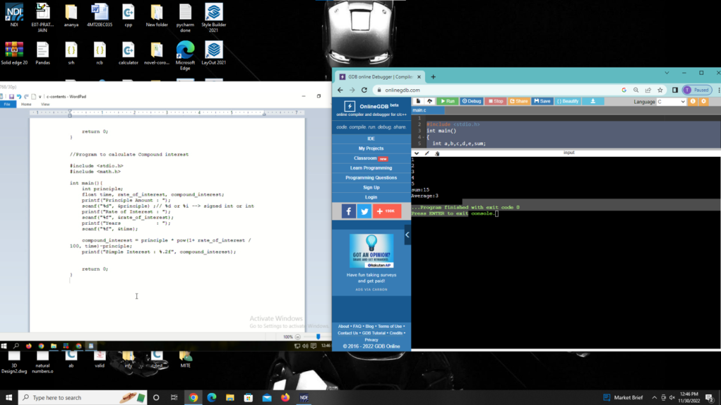

2. #include <stdio.h>

int main()

{

char product_name[20];

int quantity;

float price,bill_amount,discount=0,net_amount;

printf("product name");

scanf("%s",product_name);

printf("Quantity:");

scanf("%d",&quantity);

printf("Price:");

scanf("%f",&price);

bill_amount=quantity*price;

if(bill_amount >=5000)

discount=bill_amount*15/100;

net_amount=bill_amount-discount;

printf("Bill Amount :10.2f\n",bill_amount);

printf("Discount(-) :%10.2f\n",discount);

printf(" ==========\n");

printf(" :%10.2f\n",net_amount);

printf(" ===========\n");

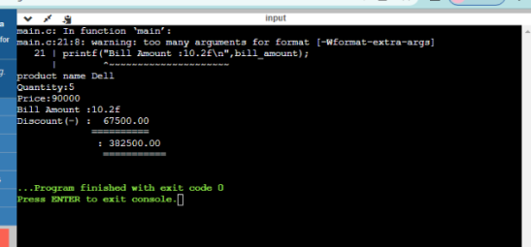

3. #include <stdio.h>

int main()

{

int x;

scanf("%d",&x);

if(x%2==0){

if(x%3==0){

printf("%d id divisible by 2 & 3",x);

}

else{

printf("%d is divisible by 2 not 3",x);

}

}

else if(x%3==0){

printf("%d id divisible by 3 not 2",x);

}

else{

printf("%d is not divisible by 2 & 3",x);

}

return 0;

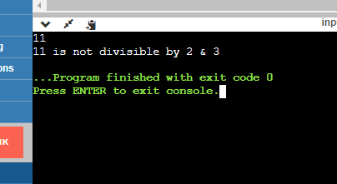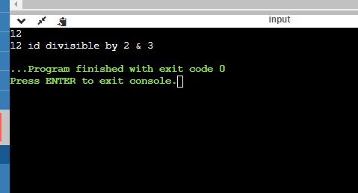

#include <stdio.h>

//Program to reverse a number

int main()

{

int num;

scanf("%d",&num);

while(num != 0){

int remainder = num % 10;

printf("%d",remainder);

num=num/10;

}

return 0;

}

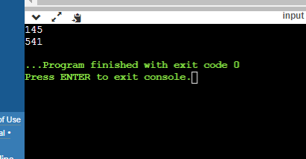

#include <stdio.h>

int main()

{

int num,reverse =0;

scanf("%d",&num);

int temp = num;

while( reverse=reverse*10+num%10,num/=10);

printf("%s",temp==reverse?"yes":"no");

return 0;

}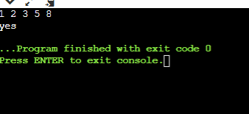

#include <stdio.h>

int main() {

int n;

char option;

do{

scanf("%d", &n);

if (n > 0)

printf("+ve");

else if (n<0)

printf("-ve");

else

printf("zero");

printf("\n\nWant to check more [Y]es/[N]o?");

scanf("%c",&option);

scanf("%c",&option);

}

while(option=='y'|| option=='y');

return 0;

}

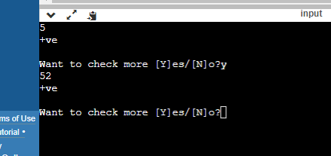

#include <stdio.h>

int main() {

for(int i =1;i<=10;i++){

if(i %4==0)

break;

printf("%d",i);

}

return 0;

}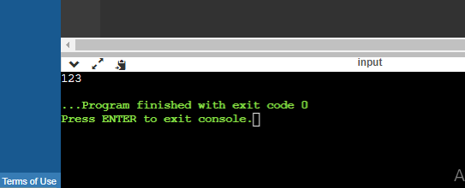

#include <stdio.h>

int main() {

for(int i =1;i<=10;i++){

if(i %4==0)

continue;

printf("%d",i);

}

return 0;

}

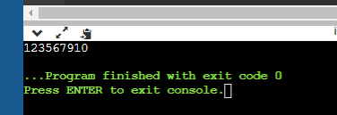 #include <stdio.h>

int main()

{

int n;

scanf("%d",&n);

for(int r =1; r<=n; r++){

for (int c =1;c<=r; c++){

printf("%d",c);

}

printf("\n");

}

return 0;

}